3 servidores (físicos y virtuales) edwin

Firewall (físicos y lógicos) jorman

2 Routers referencia Cisco 2811 maicol

4 switches capa 3 jorman

30 estaciones de trabajo jorman

2 UPS (Emergency Power Protection) jorman

Licencias Windows Server 2016 Maicol

Licencias Antivirus Licencias jorman

Licencias Windows 10 Profesional Maicol

Licencias Microsoft Office 2016 Maicol

Licencias Visual Studio Professional Maicol

2 cotizaciones ISP (Proveedor de Servicios de Internet) Min. 100 megas jorman

**Servidores fisicos**  
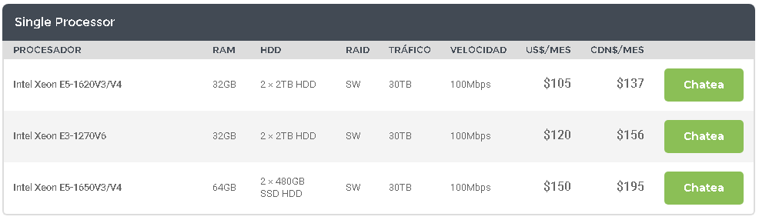

**Servidores virtuales**

**Hostinger:**

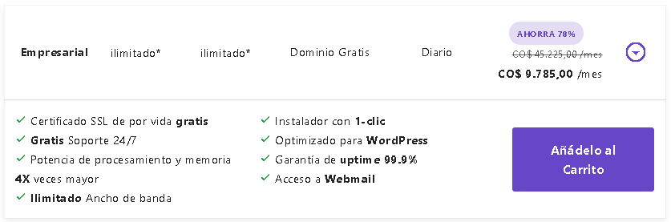

**Colombia-hosting:  
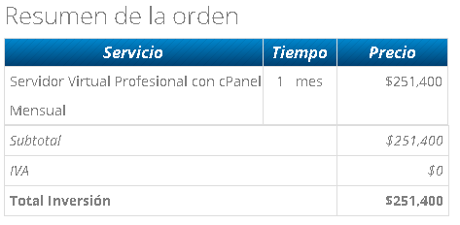**

**CaribeHost:**

**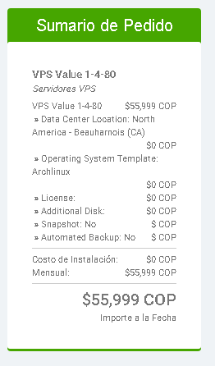  
Firewall**

**Fisico**

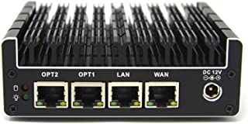

## [Protectli Vault 4 puertos, microdispositivo cortafuegos/mini PC - Intel Quad Core, AES-NI, 8GB RAM, 120 GB mSATA SSD](https://www.amazon.com/-/es/gp/slredirect/picassoRedirect.html/ref=pa_sp_atf_aps_sr_pg1_2?ie=UTF8&adId=A00446244M39MJOIYS2G&url=%2FFirewall-Appliance-Gigabit-Celeron-AES-NI%2Fdp%2FB07G9NHRGQ%2Fref%3Dsr_1_2_sspa%3Fcurrency%3DCOP%26dchild%3D1%26keywords%3Dfirewall%26qid%3D1592768405%26sr%3D8-2-spons%26psc%3D1&qualifier=1592768405&id=3541824297942993&widgetName=sp_atf)

**4.6 de 5 estrellas**

[**COP 1,341,155**](https://www.amazon.com/-/es/gp/slredirect/picassoRedirect.html/ref=pa_sp_atf_aps_sr_pg1_2?ie=UTF8&adId=A00446244M39MJOIYS2G&url=%2FFirewall-Appliance-Gigabit-Celeron-AES-NI%2Fdp%2FB07G9NHRGQ%2Fref%3Dsr_1_2_sspa%3Fcurrency%3DCOP%26dchild%3D1%26keywords%3Dfirewall%26qid%3D1592768405%26sr%3D8-2-spons%26psc%3D1&qualifier=1592768405&id=3541824297942993&widgetName=sp_atf)

**Logico**

## [Anti-Hacking Blocker Software By COMODO - Software Firewall Protection - Protects Up to 3 PC's - 1 Year PrePaid Subscription](https://www.amazon.com/-/es/Anti-Hacking-Blocker-Software-COMODO-Subscription/dp/B07RCZFGR9/ref=sr_1_4?__mk_es_US=%C3%85M%C3%85%C5%BD%C3%95%C3%91&dchild=1&keywords=firewall+software&qid=1592768807&sr=8-4)

**3.6 de 5 estrellas**

[**CD-ROM**](https://www.amazon.com/-/es/Anti-Hacking-Blocker-Software-COMODO-Subscription/dp/B07RCZFGR9/ref=sr_1_4?__mk_es_US=%C3%85M%C3%85%C5%BD%C3%95%C3%91&dchild=1&keywords=firewall+software&qid=1592768807&sr=8-4)

[**COP 95,879**](https://www.amazon.com/-/es/Anti-Hacking-Blocker-Software-COMODO-Subscription/dp/B07RCZFGR9/ref=sr_1_4?__mk_es_US=%C3%85M%C3%85%C5%BD%C3%95%C3%91&dchild=1&keywords=firewall+software&qid=1592768807&sr=8-4)

Routers referencia Cisco 2811

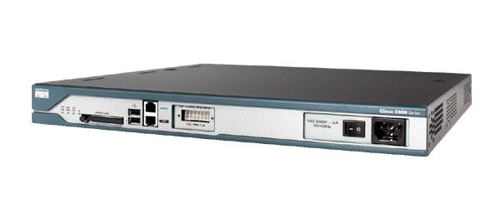

**Cantidad:** 2

**Precio :** $ 630.000

**Tasa de transferencia de datos:** 0.1 Gb por segundo.

**Dimensiones del artículo:** 16.40 x 17.25 x 1.75 pulgadas.

**Peso del artículo:** 14.00 libras.

**Rango:** pies.

**Puerto Ethernet totales:** 2

**Total routers:** $1.260.000

**Switches capa 3**

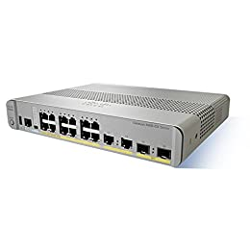

**[Cisco 3560 cx-12tc-s Layer 3 Switch ws-c3560cx-12tc-s](https://www.amazon.com/-/es/dp/B00UC5OZWM/ref=dp_cerb_1)**

[***4 de 5 estrellas***](https://www.amazon.com/-/es/product-reviews/B00UC5OZWM)

**Total 4 Switches**

**COP 2,267,281 * 4 = 9,069,124**

**Estaciones de trabajo**



## [**Escritorio esquinero en forma de L, Madera maciza, Espresso**](https://www.amazon.com/-/es/gp/slredirect/picassoRedirect.html/ref=pa_sp_atf_aps_sr_pg1_1?ie=UTF8&adId=A03881041F4UP38WSSBJ2&url=%2FSHW-L-Shaped-Office-Corner-Espresso%2Fdp%2FB07H4TGCCM%2Fref%3Dsr_1_1_sspa%3F__mk_es_US%3D%25C3%2585M%25C3%2585%25C5%25BD%25C3%2595%25C3%2591%26dchild%3D1%26keywords%3Dbusiness%2Bdesktop%2Bcomputer%26qid%3D1592769337%26sr%3D8-1-spons%26psc%3D1&qualifier=1592769336&id=3604270536989193&widgetName=sp_atf)

***4.2 de 5 estrellas***

**Total 30 Escritorios** [**COP 533,657 * 30 = 16,009,710**](https://www.amazon.com/-/es/gp/slredirect/picassoRedirect.html/ref=pa_sp_atf_aps_sr_pg1_1?ie=UTF8&adId=A03881041F4UP38WSSBJ2&url=%2FSHW-L-Shaped-Office-Corner-Espresso%2Fdp%2FB07H4TGCCM%2Fref%3Dsr_1_1_sspa%3F__mk_es_US%3D%25C3%2585M%25C3%2585%25C5%25BD%25C3%2595%25C3%2591%26dchild%3D1%26keywords%3Dbusiness%2Bdesktop%2Bcomputer%26qid%3D1592769337%26sr%3D8-1-spons%26psc%3D1&qualifier=1592769336&id=3604270536989193&widgetName=sp_atf)

**Ups (Emergency Power Protection)**

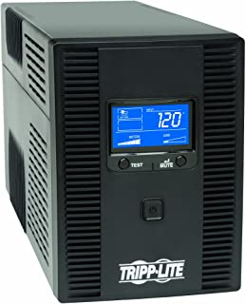

# **Sistema de alimentación ininterrumpida, de la marca Tripp Lite, AVR, 120 V, con pantalla LCD, USB y coaxial RJ45 Negro**

***4.3 de 5 estrellas***

**Total 2 Ups** [**COP 1,226,446**](https://www.amazon.com/-/es/gp/offer-listing/B009TZTGWK/ref=dp_olp_new_mbc?ie=UTF8&condition=new) **\* 2 = 2,452,892**

**Licencias Windows Server 2012**

**Windows Server 2016 Datacenter**

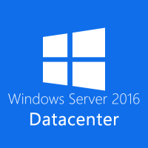

* Software Genuino
* Reinstalable
* Clave de Producto y Links de descarga
* Multilenguaje
* Disponible para descargar inmediatamente al comprar
* Soporte 24/7

**Precio:** COP $330.000

**Windows Server 2016 Standard**

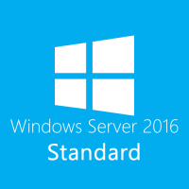

* Software Genuino
* Reinstalable
* Clave de Producto y Links de descarga
* Multilenguaje
* Disponible para descargar inmediatamente al comprar
* Soporte 24/7

**Precio:** COP $300.000

**Windows Server 2016 Essentials**

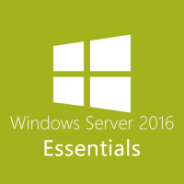

* Software Genuino
* Reinstalable
* Clave de Producto y Links de descarga
* Multilenguaje
* Disponible para descargar inmediatamente al comprar
* Soporte 24/7

**Precio:** COP $270.000

**Licencias Windows 10 Profesional**

**Windows 10 Enterprise**

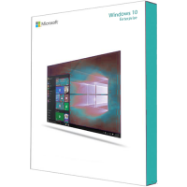

* Software Genuino
* Reinstalable
* Clave de Producto y Links de descarga
* Multilenguaje
* Disponible para descargar inmediatamente al comprar
* Soporte 24/7

**Precio:** COP $285.000

**Windows 10 Education**

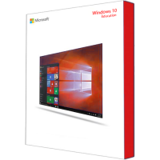

* Software Genuino
* Reinstalable
* Clave de Producto y Links de descarga
* Multilenguaje
* Disponible para descargar inmediatamente al comprar
* Soporte 24/7

**Precio:** COP $240.000

**Windows 10 Pro**

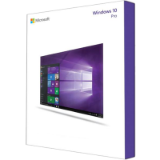

* Software Genuino
* Reinstalable
* Clave de Producto y Links de descarga
* Multilenguaje
* Disponible para descargar inmediatamente al comprar
* Soporte 24/7

**Precio:** COP $225.000

**Window 10 Home**

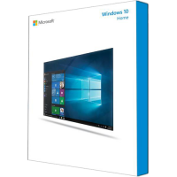

* Software Genuino
* Reinstalable
* Clave de Producto y Links de descarga
* Multilenguaje
* Disponible para descargar inmediatamente al comprar
* Soporte 24/7

**Precio:** COP $210.000

**Licencias Microsoft Office 2016**

**Office 2016 Professional Plus para PC**

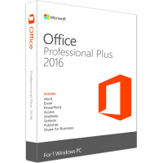

* Software Genuino
* Reinstalable
* Clave de Producto y Links de descarga
* Multilenguaje
* Disponible para descargar inmediatamente al comprar
* Soporte 24/7

**Precio:** COP $270.000

**Outlook 2016**

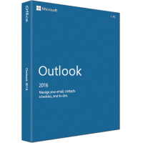

* Software Genuino
* Reinstalable
* Clave de Producto y Links de descarga
* Multilenguaje
* Disponible para descargar inmediatamente al comprar
* Soporte 24/7

**Precio:** COP $202.500

**Project 2016 Professional**

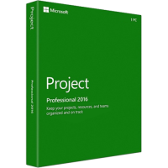

* Software Genuino
* Reinstalable
* Clave de Producto y Links de descarga
* Multilenguaje
* Disponible para descargar inmediatamente al comprar
* Soporte 24/7

**Precio:** COP $255.000

**Licencia Visual Studio Professional**



**Suscripción mensual**

**Precio:** COP $168.660

**Suscripción estándar**

**Precio:** COP $2.994.652

**Licencias Antivirus**

Norton 360 Deluxe

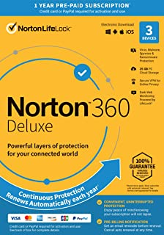

## [Norton 360 Deluxe – Antivirus software for 3 Devices with Auto Renewal - Includes VPN, PC Cloud Backup & Dark Web Monitoring powered by LifeLock [Key Card]](https://www.amazon.com/-/es/gp/slredirect/picassoRedirect.html/ref=pa_sp_atf_aps_sr_pg1_1?ie=UTF8&adId=A0754734BAU7LHUESTC8&url=%2FNEW-Norton-360-Deluxe-Monitoring%2Fdp%2FB07QFXSQFP%2Fref%3Dsr_1_1_sspa%3F__mk_es_US%3D%25C3%2585M%25C3%2585%25C5%25BD%25C3%2595%25C3%2591%26dchild%3D1%26keywords%3DAntivirus%26qid%3D1592770716%26sr%3D8-1-spons%26psc%3D1&qualifier=1592770716&id=6525499256617480&widgetName=sp_atf)

*3.9 de 5 estrellas* [CD-ROM](https://www.amazon.com/-/es/gp/slredirect/picassoRedirect.html/ref=pa_sp_atf_aps_sr_pg1_1?ie=UTF8&adId=A0754734BAU7LHUESTC8&url=%2FNEW-Norton-360-Deluxe-Monitoring%2Fdp%2FB07QFXSQFP%2Fref%3Dsr_1_1_sspa%3F__mk_es_US%3D%25C3%2585M%25C3%2585%25C5%25BD%25C3%2595%25C3%2591%26dchild%3D1%26keywords%3DAntivirus%26qid%3D1592770716%26sr%3D8-1-spons%26psc%3D1&qualifier=1592770716&id=6525499256617480&widgetName=sp_atf)

[COP 76,819](https://www.amazon.com/-/es/gp/slredirect/picassoRedirect.html/ref=pa_sp_atf_aps_sr_pg1_1?ie=UTF8&adId=A0754734BAU7LHUESTC8&url=%2FNEW-Norton-360-Deluxe-Monitoring%2Fdp%2FB07QFXSQFP%2Fref%3Dsr_1_1_sspa%3F__mk_es_US%3D%25C3%2585M%25C3%2585%25C5%25BD%25C3%2595%25C3%2591%26dchild%3D1%26keywords%3DAntivirus%26qid%3D1592770716%26sr%3D8-1-spons%26psc%3D1&qualifier=1592770716&id=6525499256617480&widgetName=sp_atf)

Norton 360 Deluxe

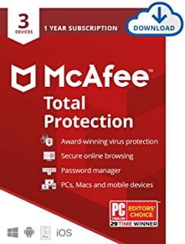

## [McAfee Total Protection 2020 Antivirus Internet Security Software, 3 Device Password Manager, Parental Control, Privacy, 12 Month - Download Code](https://www.amazon.com/-/es/McAfee-Total-Protection-Device-Download/dp/B07BFS3G7P/ref=sr_1_4?__mk_es_US=%C3%85M%C3%85%C5%BD%C3%95%C3%91&dchild=1&keywords=Antivirus&qid=1592770716&sr=8-4)

***4.2 de 5 estrellas***

[COP 96,033](https://www.amazon.com/-/es/gp/slredirect/picassoRedirect.html/ref=pa_sp_atf_aps_sr_pg1_1?ie=UTF8&adId=A0754734BAU7LHUESTC8&url=%2FNEW-Norton-360-Deluxe-Monitoring%2Fdp%2FB07QFXSQFP%2Fref%3Dsr_1_1_sspa%3F__mk_es_US%3D%25C3%2585M%25C3%2585%25C5%25BD%25C3%2595%25C3%2591%26dchild%3D1%26keywords%3DAntivirus%26qid%3D1592770716%26sr%3D8-1-spons%26psc%3D1&qualifier=1592770716&id=6525499256617480&widgetName=sp_atf)

Norton 360 Deluxe

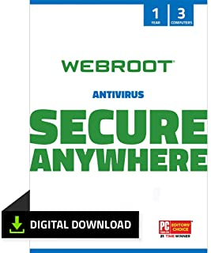

## [Webroot Internet Security with Antivirus Protection Software | 3 Device | 1 Year Subscription | PC Download](https://www.amazon.com/-/es/Webroot-Antivirus-Protection-Internet-Subscription/dp/B07DDNL2BJ/ref=sr_1_7?__mk_es_US=%C3%85M%C3%85%C5%BD%C3%95%C3%91&dchild=1&keywords=Antivirus&qid=1592770716&sr=8-7)

***4.3 de 5 estrellas*** [***Descarga de software***](https://www.amazon.com/-/es/Webroot-Antivirus-Protection-Internet-Subscription/dp/B07DDNL2BJ/ref=sr_1_7?__mk_es_US=%C3%85M%C3%85%C5%BD%C3%95%C3%91&dchild=1&keywords=Antivirus&qid=1592770716&sr=8-7)

[COP 76,396](https://www.amazon.com/-/es/Webroot-Antivirus-Protection-Internet-Subscription/dp/B07DDNL2BJ/ref=sr_1_7?__mk_es_US=%C3%85M%C3%85%C5%BD%C3%95%C3%91&dchild=1&keywords=Antivirus&qid=1592770716&sr=8-7)

**ISP (Proveedor de Internet)**

**120 Megas de Internet Tigo**



**Total 120 megas de internet Tigo**

[**COP**](https://www.amazon.com/-/es/gp/offer-listing/B009TZTGWK/ref=dp_olp_new_mbc?ie=UTF8&condition=new) **$140.000 Mensuales**

**CLARO   
200 MEGAS   
300 MEGAS**